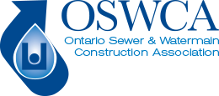

MEMBER BULLETIN

March 11th 2024

Building Infrastructure Safely Act, 2024 Receives Royal Assent

The Government of Ontario recently announced that Bill 153 - Building Infrastructure Safely Act, 2024 has reached royal assent which amends the Ontario Underground Infrastructure Notification System Act, 2012 (OUINS) also referred to as the One Call Act.

The following changes take effect May 1, 2024.

No Charging for Locates - Infrastructure owners and operators are prohibited from charging for the locates they provide.

Portions of Excavator Recourse Repealed – Excavators are no longer able to contact the Ontario Land Tribunal to seek compensation for losses or expenses for late locates, note this does not prohibit an excavator seeking compensation through traditional legal options.

Excavators can still seek compensation through the Ontario Land Tribunal if an infrastructure owner has provided inaccurate locates or clearance.

For more information on the Building Infrastructure Safely Act, 2024, please contact Steven.crombie@oswca.org or 416-618-9839

